Project 1 Report Requirements

Title Page
- Title of the Project:
- Student's Name(s)
- Student ID
- Course/Subject: CS-646 Network Protocols Security
- Instructor's Name
- Institution Name
- Date of Submission
Abstract
- Summary of the Project: Brief overview including the objectives, key findings, and conclusions.
Table of Contents
- List of Sections and Subsections with Page Numbers
Section 1: Project Overview
- Introduction
- Overview of the project aims and objectives.
- Explain ARP poisoning Attack and its impact.
- Give a brief overview of Tcpdump, Ettercap and Arpwatch.
- Network Design (can be taken from Project file)
- A table showing the IP Addresses of each VM, Default Gateway and DNS.
.
Section 3: Technical Implementation Details
3.1 Task 1 : ARP inspection
Complete all the tasks given below and provide screen shots for each task
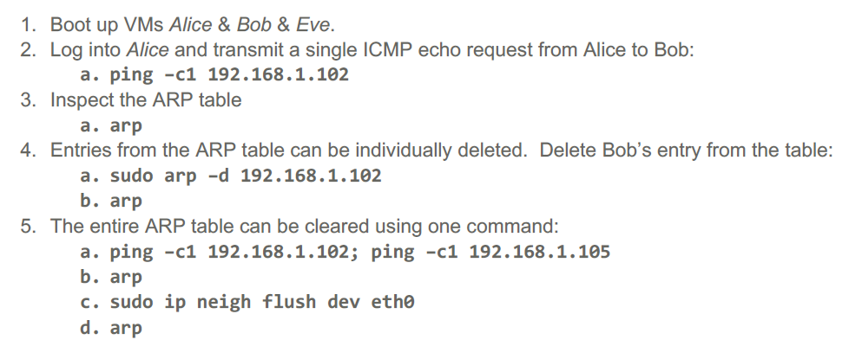
3.2 Task 2: TCP Dump
Complete the tasks listed below and provide screen shots for each task.
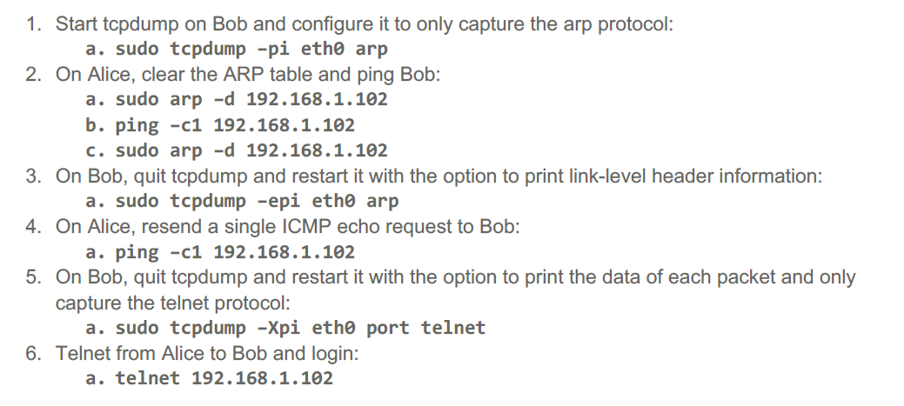
3.3 Task 3: Ettercap
Complete the tasks listed below and provide screen shots for each task.
- Scan all the network using Ettercap to identify live hosts
- Select Bobs Machine as Target 1 and Gateway as Target 2
- Launch ARP poisoning attack on Bob’s Machine
- Go to Bob’s Machine and check ARP cache to verify that the Arp poisoning attack is successful
- Visit the URL given below from Bobs machine and entery a dummy username and password
http://testphp.vulnweb.com/login.php
- Verify the Ettercap was able to capture the username and password you entered.
- Stop the Arp poisoning attack
3.3 Task 4: Arapwatch
Complete the tasks listed below and provide screen shots for each task.
- Install and configure Arpwatch on Bob’s Machine
- Relaunch Arp poisoning attack using arpspoof (Not Ettercap)
- Verify that Arpwatch generates alerts when Arp poisoning is in progress.
- Configure Arpwatch to send email of Arp poisoning attack (Bonus credit)

Section 4: Conclusion
- Summarize your findings.
- Suggest preventive measures for Arp poisoning attacks.
- Issues faced during implementation and how they were resolved.
Section 5: References
- List of references and resources used.
- References to online resources, software documentation, and academic papers.

